**Project Development Phase**

**Project Development - Delivery of Sprint-2**

|  |  |
| --- | --- |
| Date | 10 November 2022 |
| Team ID | PNT2022TMID38310 |
| Project Name | Estimate the Crop Yield using Data Analytics |

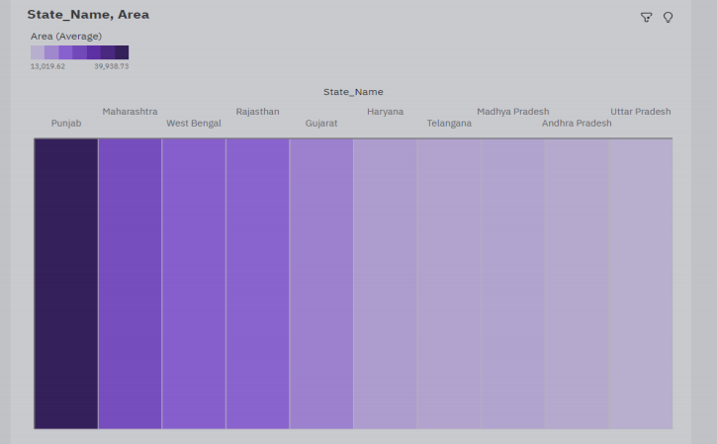TOP 10 STATES WITH MOST AREA :

